

z

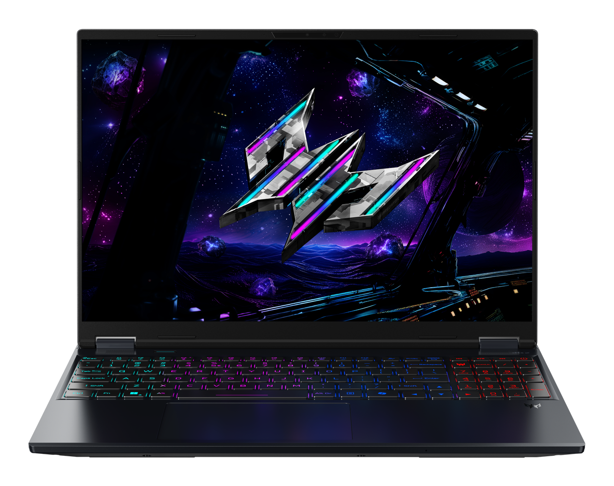

PREDATOR HELIOS NEO 16S AI

SPECIFICATIONS PREDATOR HELIOS NEO 16S AI PHN16S-I71

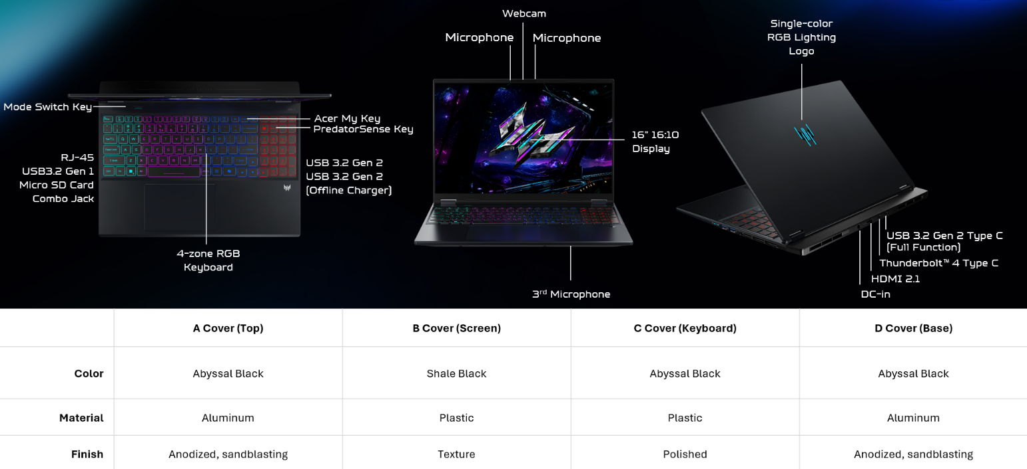
Operating System |  | Windows 11 Home
CPU and Chipset |  | Intel® Core™ Ultra 7 processor 270HX Plus |  |  |  |  | Intel® Core™ Ultra 9 processor 290HX Plus
Memory |  | Dual-channel DDR5 SDRAM support |  |  |  |  | Up to 64 GB of DDR5 system memory using two soDIMM modules
Display  6 |  | 16.0" display with OLED (Organic Light-Emitting Diode) technology, WQXGA 2560 x 1600, high-brightness (500 nits, typical value) Acer CineCrystal™  - 16:10 aspect ratio, color gamut DCI-P3 100%(Typical value),  - support 165Hz/240Hz certified by True Black HDR 500(@HDR 500, brightness reach 500 nits),  - Nvidia Advanced Optimus capable.  - Wide viewing angle up to 178 degrees  - Mercury free, environment friendly
Graphics |  | NVIDIA® GeForce RTX™ 5070 |  |  | NVIDIA® GeForce RTX™ 5070 Ti |  |  |  | NVIDIA® GeForce RTX™ 5080
Audio |  | DTS® X:Ultra Audio, featuring optimized Bass, Loudness, Speaker Protection with up to 6 custom content modes by smart amplifier |  |  | Supported in Windows Spatial Sound for PC Gaming with DTS  license integrated |  |  |  | Immersive audio rendering over headphones and internal speakers
 |  | High SNR DAC with 2.1 Vrms out capability and can driver high impedance headphone (up to 600 ohm)  Hi-Res Audio Certification by JAS (Headphone Output setting supported up to 24bit /192KHz) |  |  | Acer Purified.Voice technology with AI noise reduction in dual built-in microphones. Features include far-field pickup, dynamic noise reduction through neural network, adaptive beam forming, and predefined personal and conference call modes. |  |  |  | Compatible with Cortana with Voice  Acer TrueHarmony technology for lower distortion, wider frequency range, headphone-like audio and powerful sound
Storage |  | Solid state drive (2 slots) : 512 GB / 1 TB / 2 TB, PCIe Gen4, 16 Gb/s, NVMe 1, 5
Webcam |  | UFC with Narrow USB FHD camera + IR camera with blue glass  Windows compatible only | 1920 × 1080 resolution | 1080p video fps with Temporal Noise Reduction | Blue glass lens | Staggered High Dynamic Range (SHDR) | Dual Mic (33 mm + 33 mm) | 88 × 3.2 × 2.6 mm
Wireless and Networking |  | WPAN: Supports Bluetooth® 5.4 or above  WLAN: Intel® Killer™ DoubleShot™ Pro  Killer™ Wireless Wi-Fi 6E 1675i  802.11 a/b/g/n/ac/ax wireless LAN  2.4 GHz, 5 GHz and 6 GHz bands  2x2 MU-MIMO technology  CNVi interface support | LAN: Killer™ Ethernet E3100G |  2.5G Ethernet  Killer Software Features: Killer Control Center  Lag and Latency Reduction™ Technology  Advanced Stream Detect™ 2.0 |  Killer DoubleShot™ Pro enabled & GameFast™ Technology
Security |  | Firmware Trusted Platform Module (TPM) solution | BIOS user, supervisor passwords | Kensington lock slot
Dimensions and Weight |  | Dimensions  356.78 (W) x 275.5 (D) x 12/18.9 (H) mm (14.05 x 10.85 x 0.47/0.74 inches) |  |  |  | Weight  2.2 kg (4.85 lbs.) with 4-cell battery pack
Power Adapter and Battery |  | Power Adapter  • 3-pin 230 W 5.5 PHY PCR 50% AC adapter  • 157.0 (W) x 85.5 (D) x 25.4 (H) mm (6.18 x 3.37 x 1.00 inches)  • 19.5 V / 11.8 A output  • 640 g ± 10% with 180 cm DC cable  • Black with Acer logo  • Brick-type AC pins |  | Battery  • 92 Wh 4-cell Li-ion battery  • For OLED models: Up to 6 hours based on MobileMark® 2030 test results  • Up to 11 hours based on video playback test results
Input and Control |  | Keyboard  103 US / 104 UK / 107 JP keys | FineTip RGB backlight | Dedicated numeric keypad | International language support  • 1.5 mm key travel  • Acer My Key programmable key  • Microsoft Copilot key  • Dedicated Predator Sense key  • Caps Lock and microphone mute indicators  • Function Lock |  | Touchpad  Multi gesture touchpad | Two finger scroll | Pinch zoom | Multitasking gestures  • Microsoft Precision Touchpad certified  • Moisture resistant |  |  |  | Control Keys  Mode key | Copilot key
Windows Desktop Apps |  | In-House Applications  Acer LiveArt | Acer QuickPanel | Acer VisionArt | PredatorSense V5 (NB) |  |  |  | Tools  Acer My Key Application
Warranty |  | One-year International Travelers Warranty (ITW)
Disclaimers
• | Specifications vary depending on model.
• | Shared system memory may be allocated to support graphics, depending on system memory size and other factors. Actual system memory available to the operating system will be reduced by any memory used by the graphics solution and resources required by the operating environment.
• | Memory speed may vary depending on the CPU, chipset, or memory installed.
• | All brands and product names mentioned herein include trademarks of their respective companies and are used solely to describe or identify the products.
• | 1 GB equals 1 billion bytes. Actual formatted capacity is less and may vary depending on preloaded materials and operating environment. Acer Recovery Management uses a portion of the stated hard disk capacity as dedicated backup space.
• | Minor variations in system dimensions are possible due to the manufacturing process.
• | Weight may vary depending on product configuration, vendor components, manufacturing variability, and selected options.
• | Listed battery life is based on testing using video playback. The test clip loops and continues to run without interruption or any other inputs until the battery is drained. Stated battery life is for comparison purposes only. Actual battery life varies by model, configuration, applications, video format, and features used. A battery’s maximum capacity decreases with time and use. Battery life test configuration: 15th Gen Intel® Core™ U9 Refresh processor, NVIDIA® GeForce RTX™ 5070 GPU, WQXGA+ OLED display, SSD only, and 16 GB of DDR5 memory. Battery life test conditions: LCD brightness set to 150 nits, headphones connected, WLAN off, Bluetooth off, and Better Battery Mode enabled.
• | Actual battery life may vary considerably depending on product model, configuration, applications, power management settings, operating conditions, and features utilized. Performance variation may also arise based on components in use, including but not limited to the processor, RAM capacity, storage, display, and resolution.
• | Bundled software may vary depending on hardware configuration, operating system, and regional availability.

